Step 1: set up environment
- Install make, wget, bash, this is the most important step in this tutorial
- You must set up bash to follow it
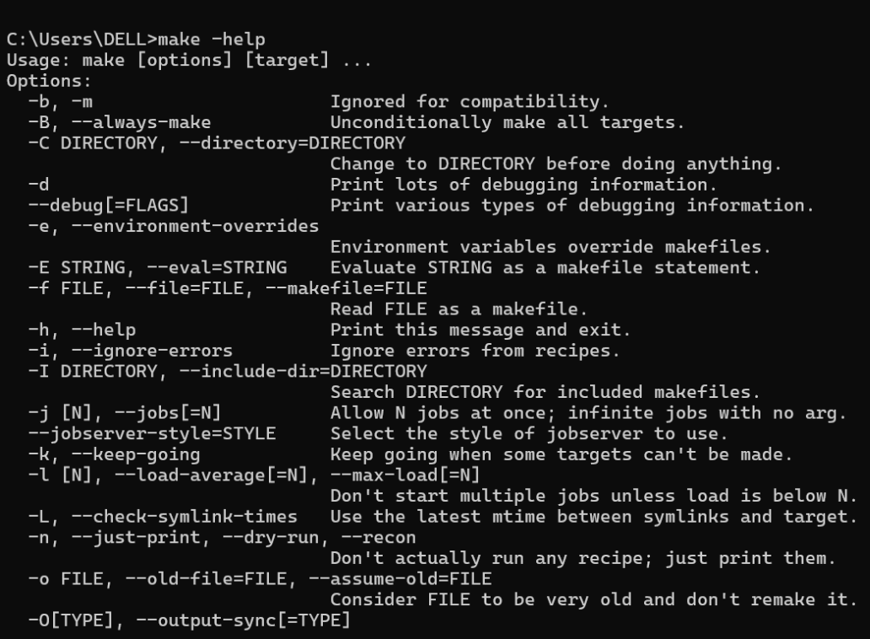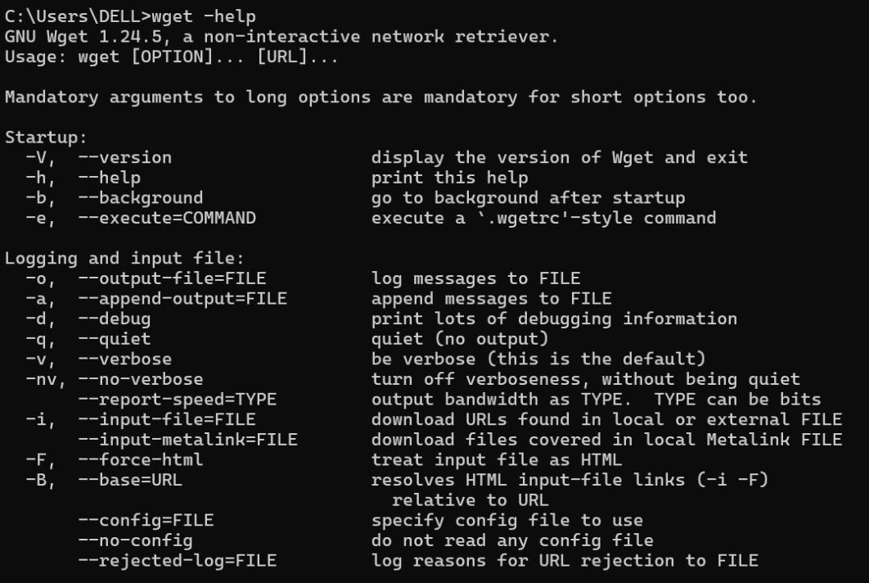

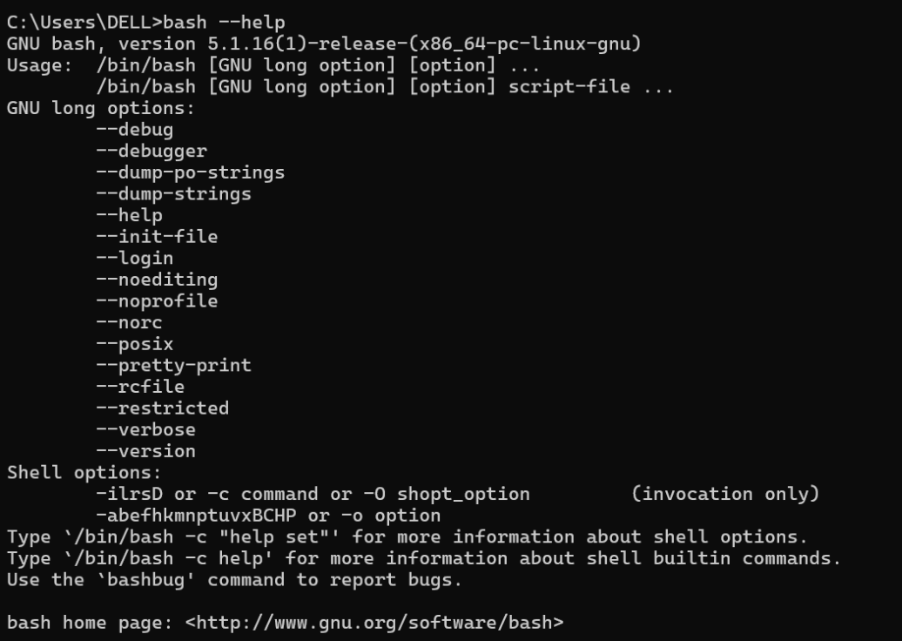

Step 2: create tesstrain(anywhere)
git clone https://github.com/tesseract-ocr/tesstrain.git
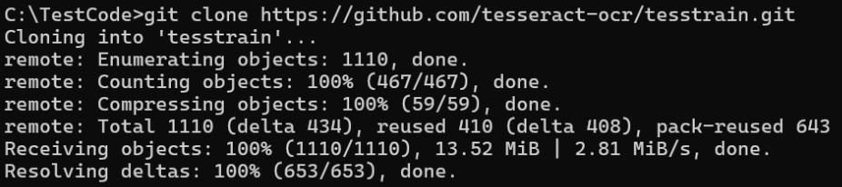
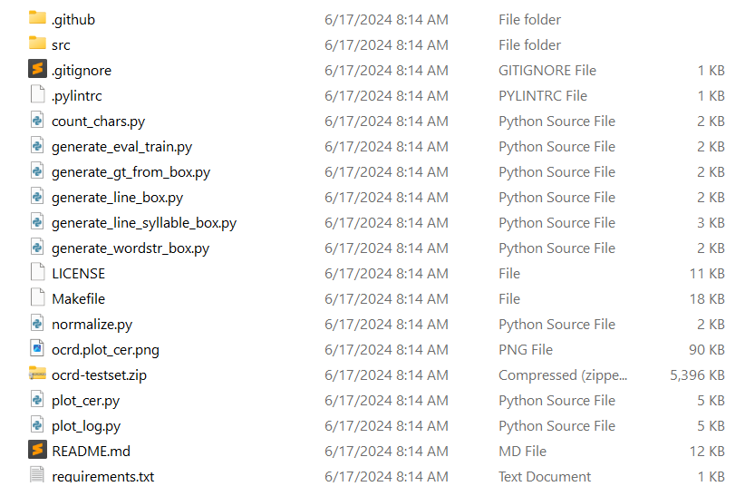

Step 3: make langdata
Point to tesstrain and run this:
make tesseract-langdata
You need to have wget and make to run this command. It may take a while
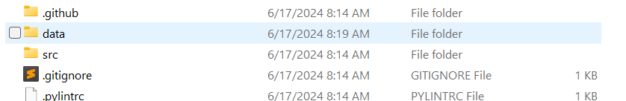
Now you have a subdir named data in your tesstrain

Step 4: create ground truth data
____________________________________________________________________________
- Crop image by line and label it. You need to create the label file with gt.txt extension and corresponding name to the image file. See below:
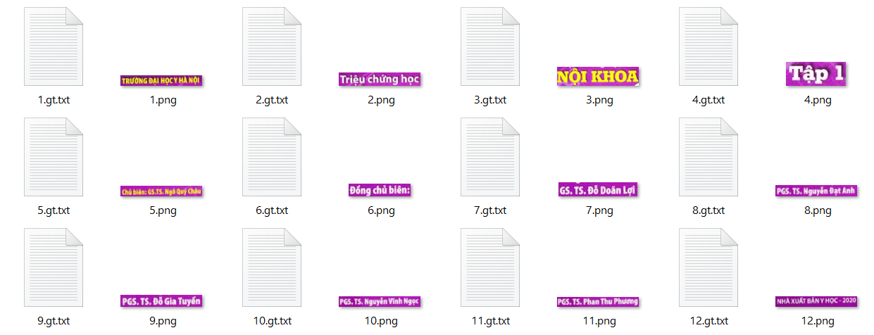
____________________________________________________________________________
- You can install R and run this to make labeling process faster:
install.packages("remotes") # only if `remotes` is not installed
remotes::install_github("arcruz0/tesseractgt")

library(tesseractgt)
create_gt_txt(folder = "alg-ground-truth", # folder with images
extension = "png", # extension of image files
engine = tesseract::tesseract(language = "eng"))

See also about the packages
See also about cropping text line
____________________________________________________________________________
- Move your lan-ground-truth to your data folder
Attention: you need to to set the name for your ground truth folder with this format
{langname}-ground-truth
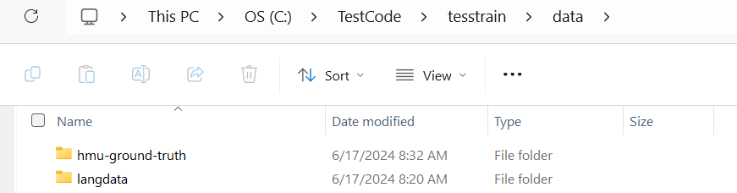
____________________________________________________________________________

Step 5: create base data for fine-tuning
- Create folder like this in your tesstrain
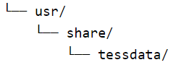
Download base data and save it in tessdata folder

OR you can run this command
wget -P usr/share/tessdata https://github.com/tesseract-ocr/tessdata_best/raw/main/eng.traineddata
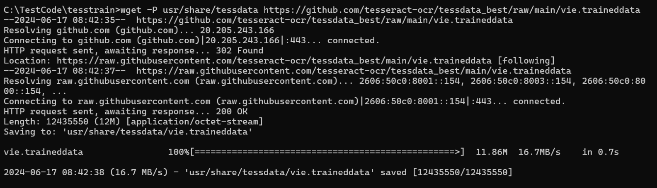
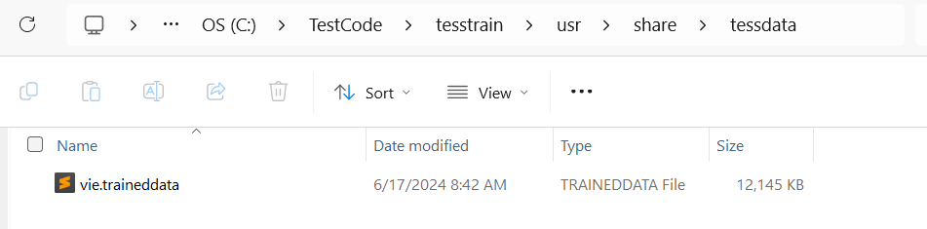

Step 6: fine-tune
- Open your bash and run this command: make training MODEL_NAME=alg START_MODEL=eng FINETUNE_TYPE=Impact
- If you got this error
solve it using sudo apt get dos2unix

Step 7: using new model
- Find your tessdata in your base tesseract-ocr folder and paste the new trained data into it
